**Kitchen Story**

**(Fast Food Portal)**

* **Content**

1. Project and Developer Details
2. Sprints Planned and the Tasks Achieved in them
3. Algorithms and Flowcharts of the Application
4. Core Concepts Used in the Project
5. Functionality & Features of Sporty Shoes Application
6. Links to the GitHub Repository
7. Your conclusion on enhancing the application and defining the USPs

**1. Project and Developer Details**

**Project Objective ->**

* As a Full Stack Developer, complete the features of the Kitchen Story E-commerce portal by planning the development and pushing the source code to the GitHub repository.

**Application Features ->**

* After running of angular application, User/Admin will have to Authenticate (Sign In) before accessing any functionality.
* You have to Authenticate with user name and password.

1. Functionality Applicable Irrespective of Role

* Sign Up (Register New User)
* Sign In (Authenticate)
* Reset Password

1. If logged in as **Admin.** Admin can –

* Fetch All Food Items
* Add New Food Item
* Delete Food Item

1. If logged in as **User.** User can –
   * Search for Food Item and Purchase it.

**Developer Details ->**

1. **Name :** Shreyash Vijay Pawar
2. **Designation :** Developer
3. **IDE used :** VS Code
4. **Server Used :** JSON Server
5. **Analysis & Testing :** Developer Tools (Google Chrome)
6. **Framework :** Bootstrap 4.6

**2. Sprints Planned and the Tasks Achieved in them**

|  |  |  |  |  |  |  |
| --- | --- | --- | --- | --- | --- | --- |
| Sprint | Task | Developer | Estimated Time (Hrs) | Actual Time (Hrs) | Remaining Time (Hrs) | Status |
| #1 | Analysis Finished | Shreyash | 1 | 1 | 0 | Complete |
| JSON Server Backend | Shreyash | 2 | 2 | 0 | Complete |
| App Home | Shreyash | 4 | 4 | 0 | Complete |
| Admin - Add New Item | Shreyash | 4 | 4 | 0 | Complete |
| #2 | Admin - All Food Items | Shreyash | 4 | 4 | 0 | Complete |
| User - Search based on Category | Shreyash | 2 | 2 | 0 | Complete |
| Auth Guards | Shreyash | 3 | 3 | 0 | Complete |
| Documentation | Shreyash | 2 | 2 | 0 | Complete |

**3. Algorithms and Flowcharts of the Application**

1. Authentication -->>

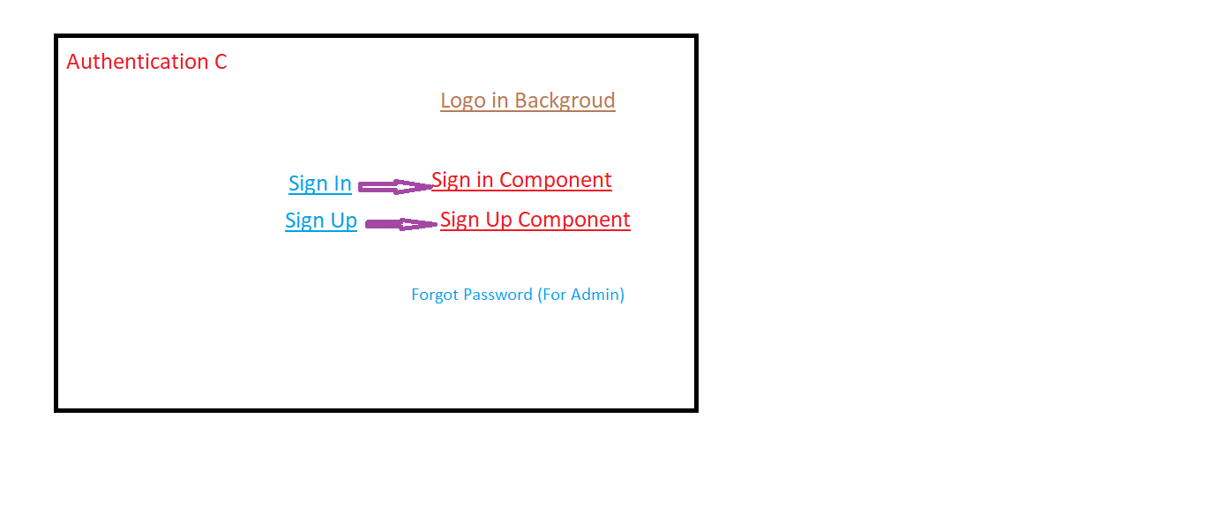

2. Admin Functionality -->>

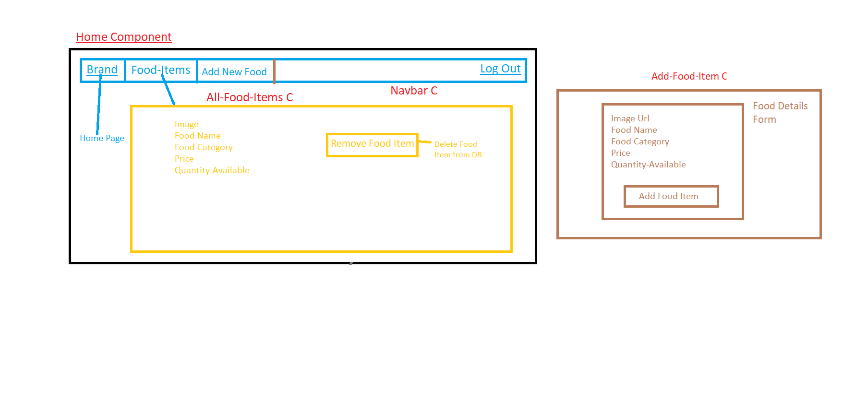

3. User Functionality -->>

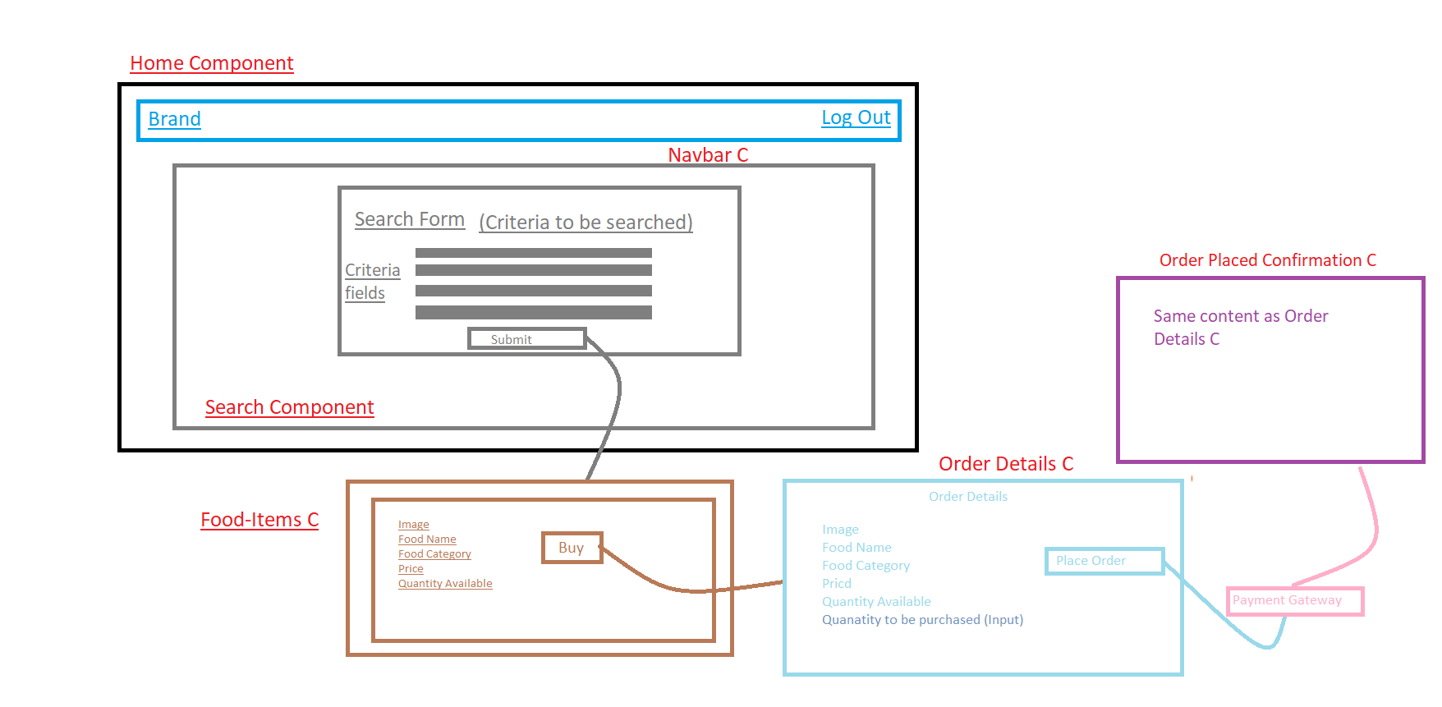

**4. Core Concepts Used in the Project**

1. JSON
2. Angular
3. Angular CLI
4. HTML
5. CSS
6. Bootstrap Framework
7. Typescript

**5. Functionality & Features of Sporty Shoes Application**

**A. Functionality Irrespective of Roles**

1. **Sign Up (Register New user)**

**URL:** http://localhost:4200/sign-up

**Screenshot:**

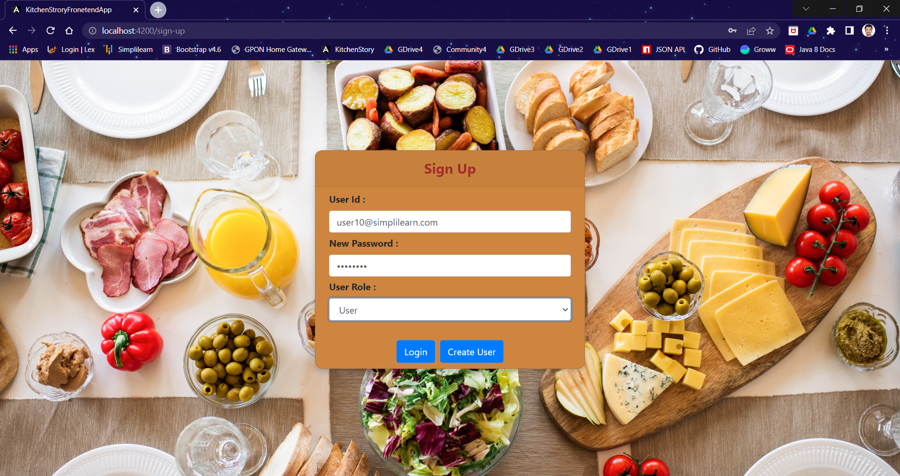

1. **Sign In (Authentication)**

**URL:** http://localhost:4200/

**Screenshot:**

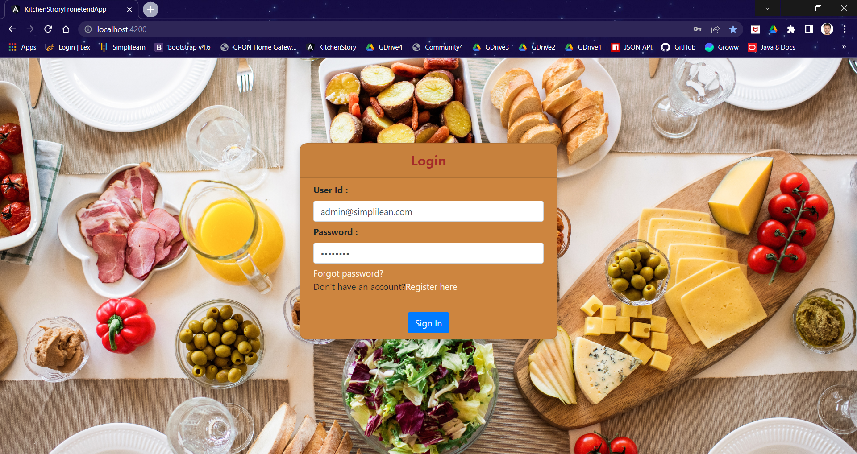

1. **Password Reset Functionality**

**URL:** http://localhost:4200/passoword-reset

**Screenshot:**

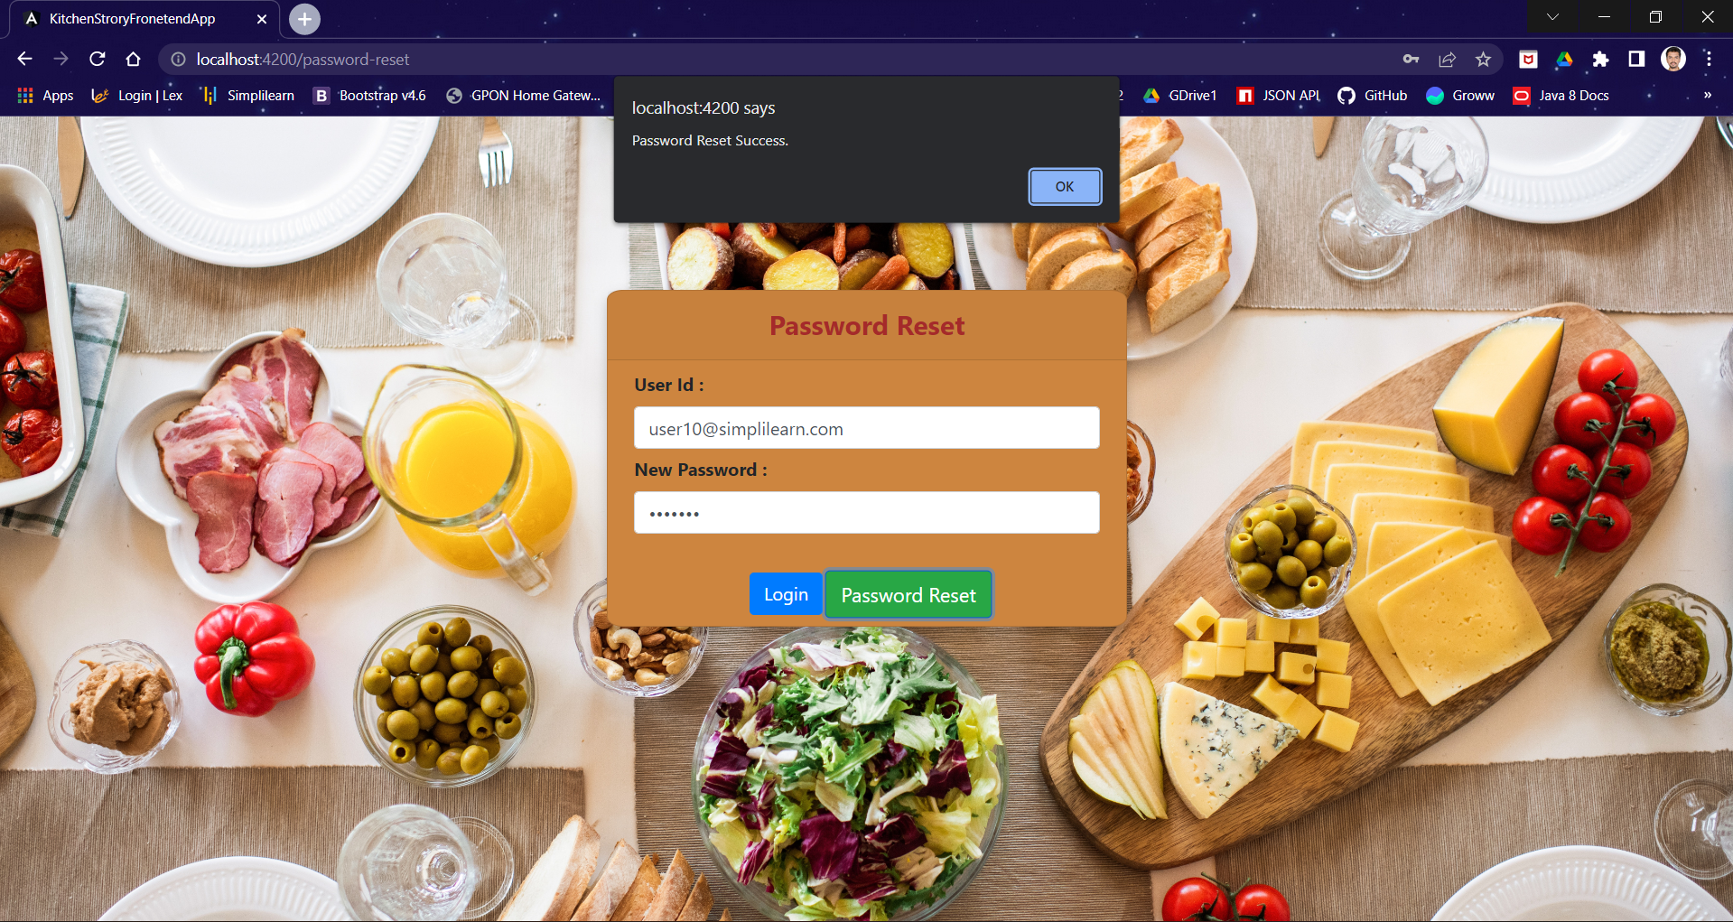

**B. Login as Admin**

1. **Home Page**

**URL:** [http://localhost:4200/api/](http://localhost:4200/api/all-food-items)

**Screenshot:**

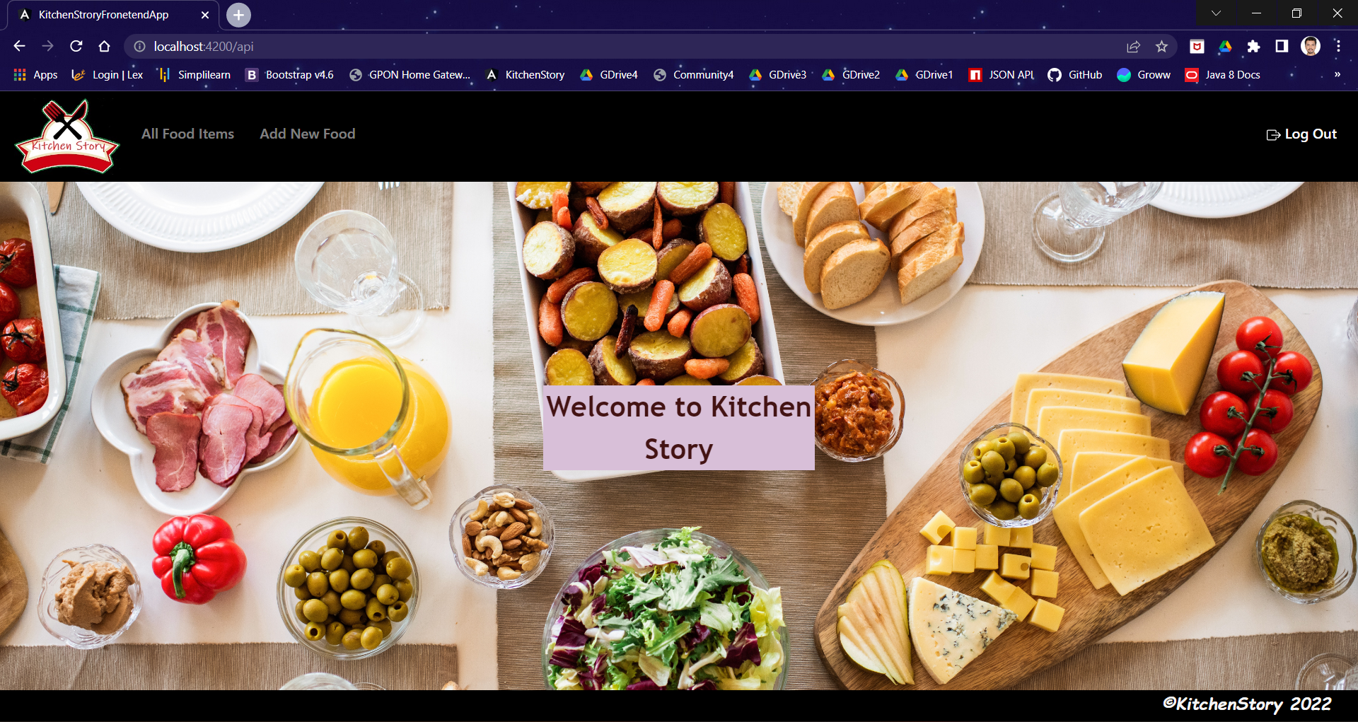

1. **Get All Food Items Functionality**

**URL:** <http://localhost:4200/api/all-food-items>

**Screenshot:**

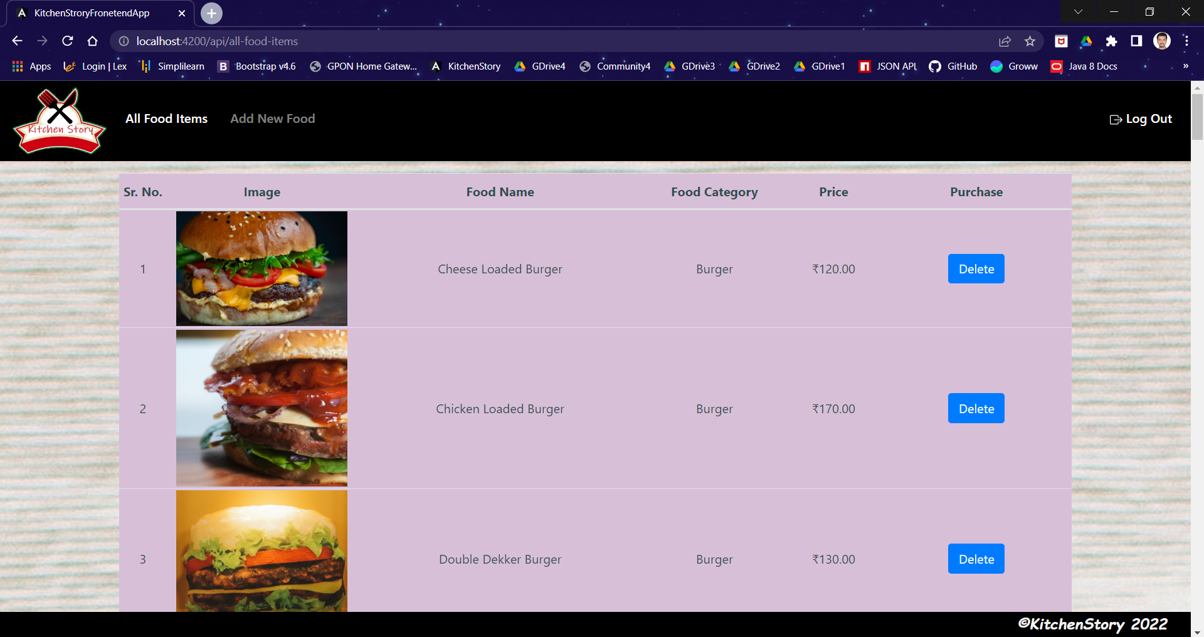

1. **Delete Food Item Functionality**

**Screenshot:**

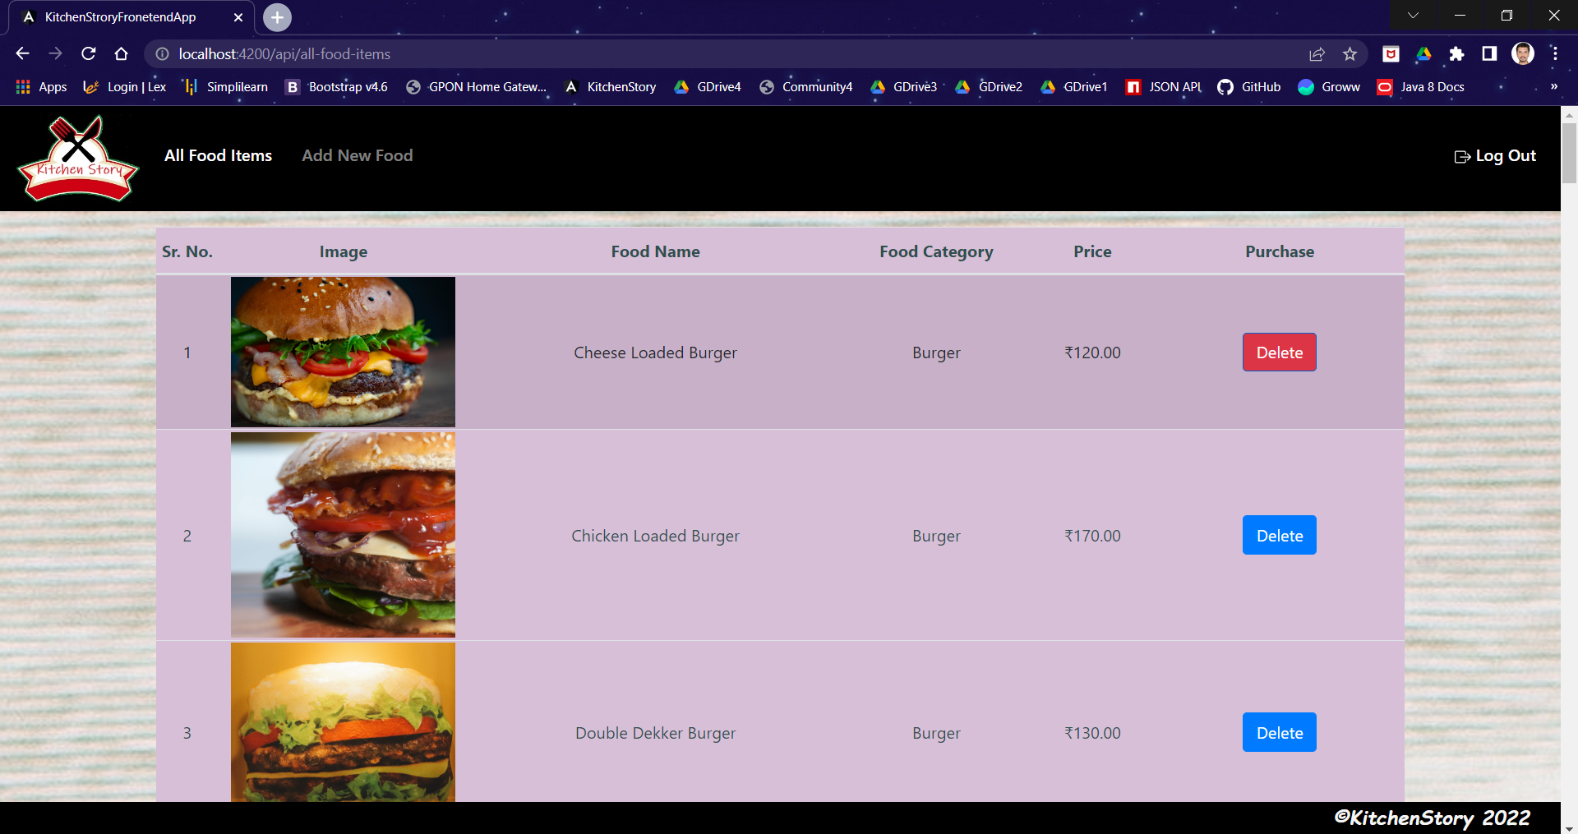

1. **Add Food Item Functionality**

**URL:** http://localhost:4200/api/add-new-food

**Screenshot:**

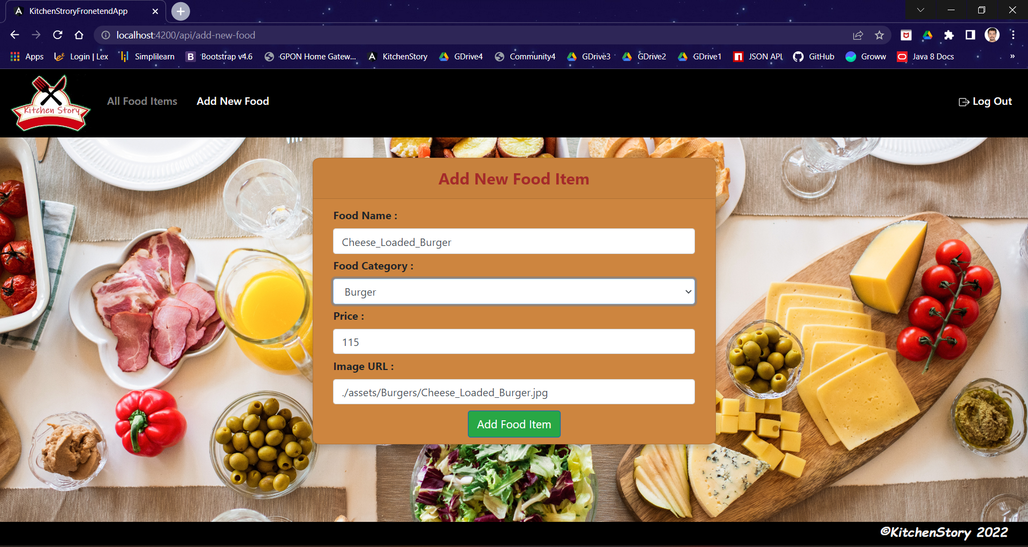

**C. Login as User**

1. **Home Page**

**URL:** http://localhost:4200/api

**Screenshot:**

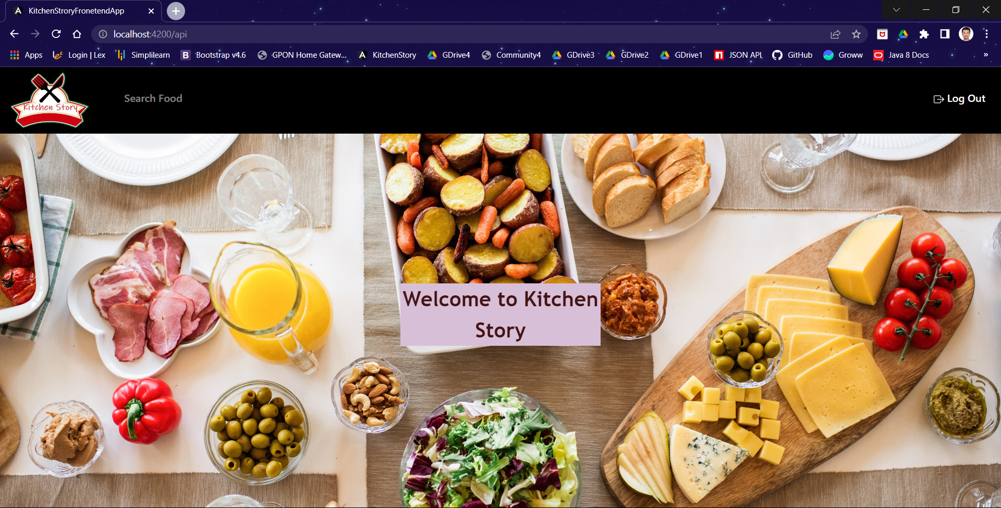

1. **Search Food Item Functionality**

**URL:** http://localhost:4200/api/search

**Screenshot:**

* **Search Page**

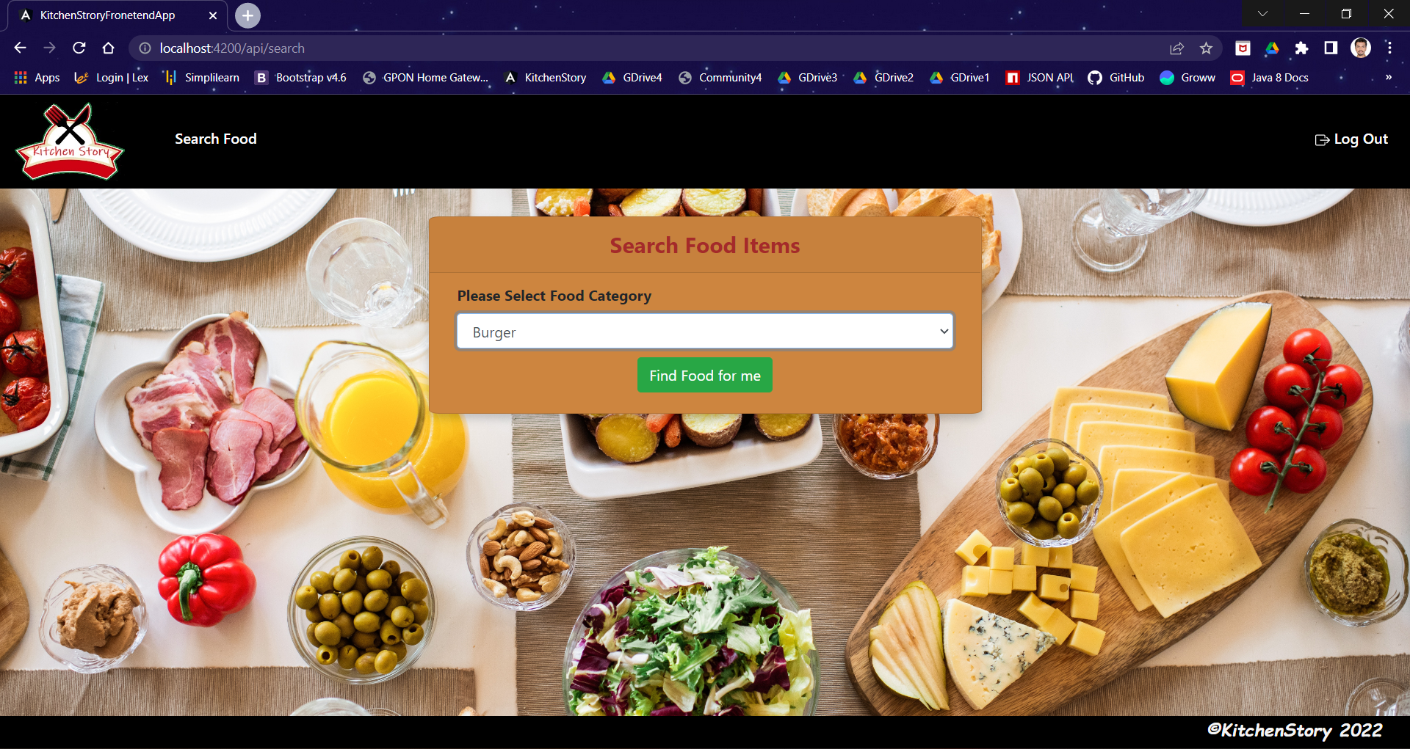

* **Available Food Items**

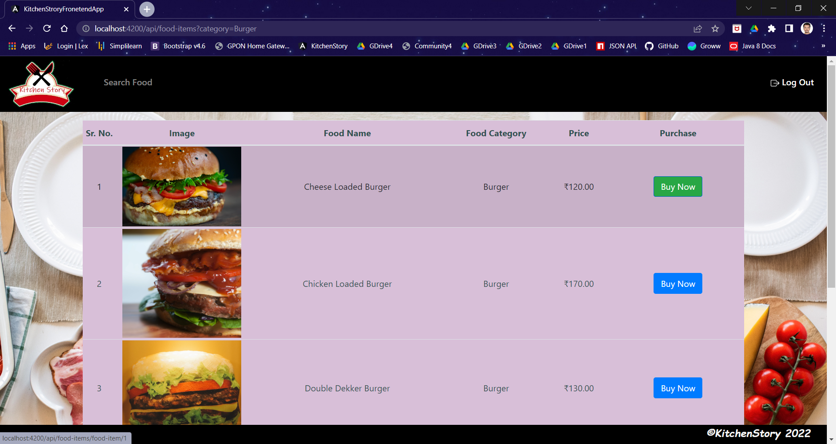

* **Order Summary**

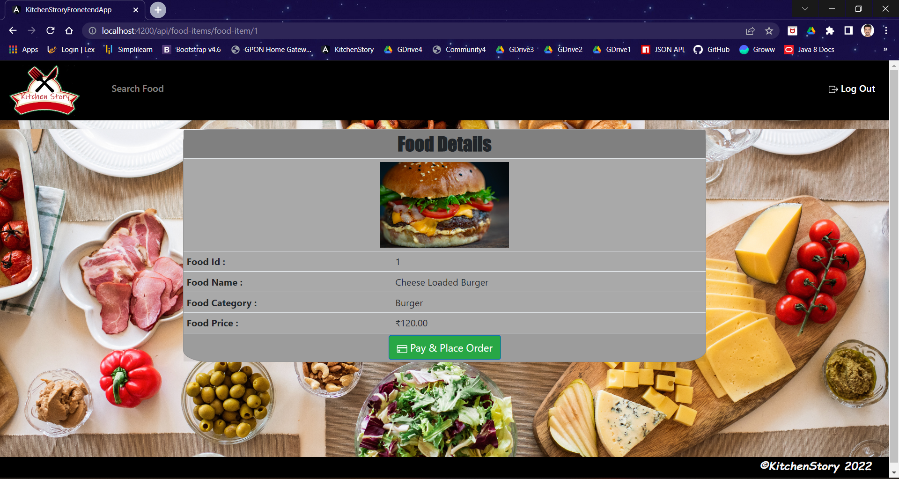

* **Order Placed Page**

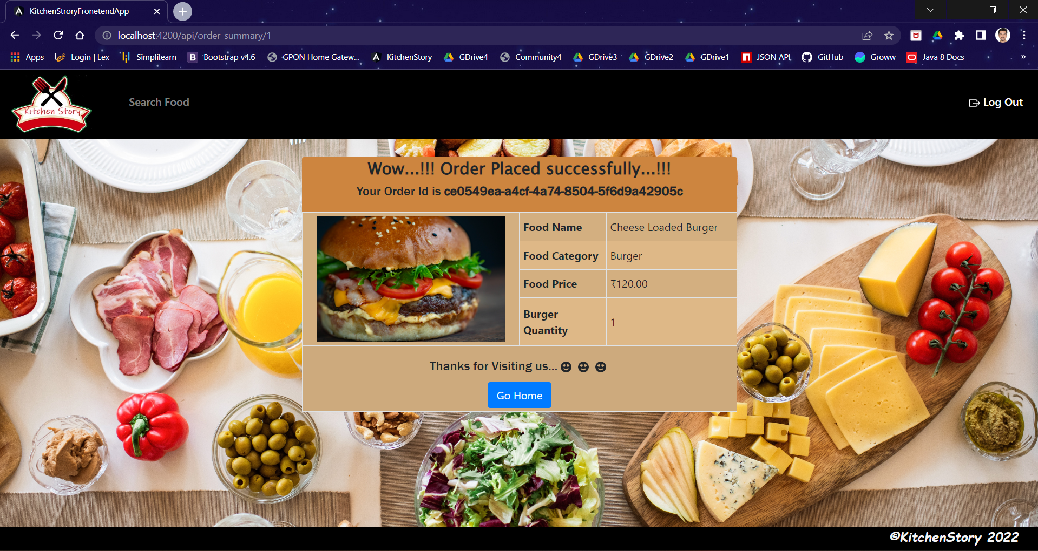

**6. Links to the GitHub Repository & Notes**

1. **Link:** <https://github.com/ShreyashVijayPawar/KitchenStoryFrontend.git>
2. **Note:**
3. Code present in master branch
4. Before Testing application, make sure Node JS, Angular CLI, JSON server, VS Code (or any other IDE) installed in your system.

Steps:

* + - Install JSON server in your system

**🡪 npm install -g json-server**

* + - Start JSON server to watch **db.json** file.

**🡪 json-server --watch db.json**

**Note: db.json file is present is root path. -->> **

* + - Import project from GitHub run below command –

**🡪 ng s**

1. Admin username will be **admin@simplilearn.com** and password will be **password**.
2. If you try to access URL which you are not authorized to, you will get alert that you are not authorized or authenticated accordingly.

**7. Your conclusion on enhancing the application and defining the USPs (Unique Selling Points)**

1. **Enhancements –**

* Functionality for Admin to sort data by applying filter after fetching all food-items.
* Functionality for User check order status.

1. **Unique Selling Points (USP)**

* User Friendly Application
* Versatile and Scalable